Documentation
1.Table Creation (CREATE): Write the SQL statements to create a database named “employee” and the following tables based on the provided schema:
- Departments
- Location
- Employees

Created a database named employee and created the three required tables — Departments, Location, and Employees — according to the provided schema.

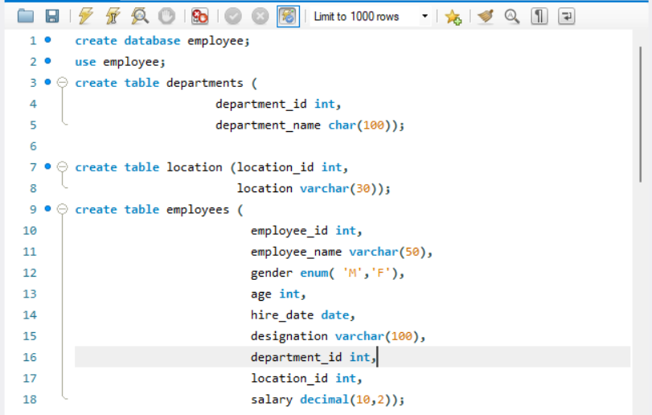
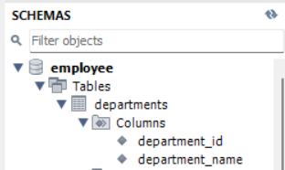

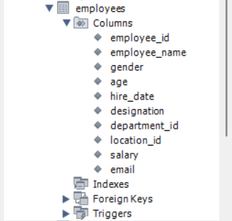

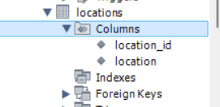

2. Table Alteration (ALTER): Consider the following scenarios and write the SQL statements to alter the structure of the tables accordingly:
- Add a new column named "email" to the Employees table to store employee email addresses.
Added a new email column to the Employees table to store employee email addresses.
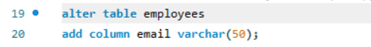
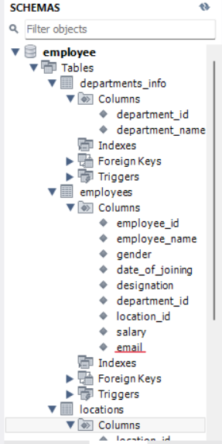

- Modify the data type of the "designation" column in the Employees table to support a wider range of values.
Modified the designation column in the Employees table to support a wider range of values by increasing its size from VARCHAR(100) to VARCHAR(200).

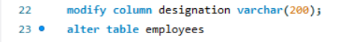

- Drop the “age” column from the Employees table.
Removed the age column from the Employees table as required.



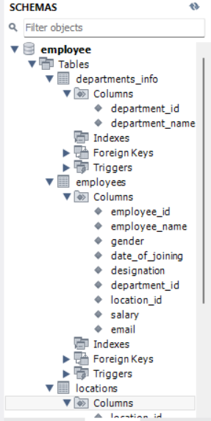

- Rename the “hire_date” column to “date_of_joining”.
Renamed the hire_date column in the Employees table to date_of_joining
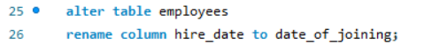

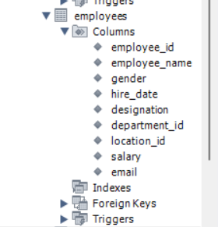
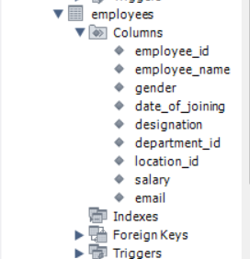

3. Table Renaming (RENAME): Rewrite the SQL statements to rename the following tables:
- Rename the "Departments" table to "Departments_Info".

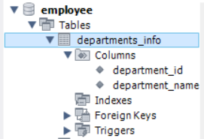

- Rename the "Location" table to "Locations".



4.Table Truncation (TRUNCATE): Write an SQL statement to truncate the Employees table.
- Truncated the Employees table to remove all records while keeping the table structure intact.

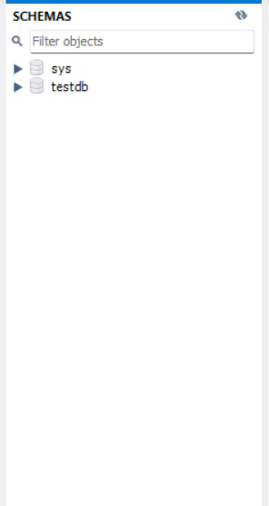
5.Database & Table Dropping (DROP): Write the SQL statements to drop the Employees table and then the “employee” database.
Dropped the Employees table from the employee database using the DROP TABLE command.
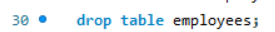
Dropped the employee database using the DROP DATABASE command.


Constraints
- Database Recreation:
Drop the 'employee' database if it exists and recreate it using the provided schema, ensuring that all tables are created with the appropriate constraints as instructed.

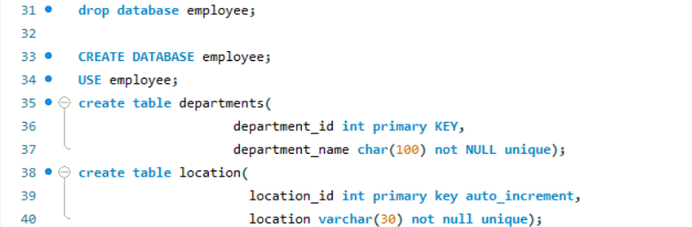

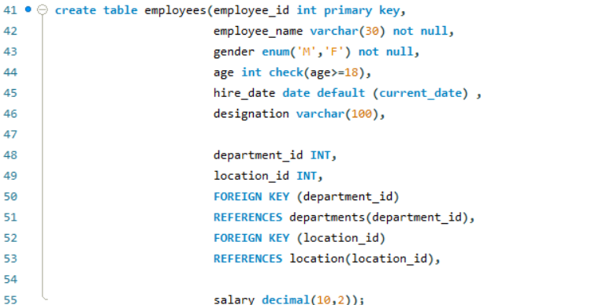

Departments Table:
1.Ensure that the "department_id" uniquely identifies each department.
2.Set up constraints on the "department_name" to avoid duplicate and null entries.

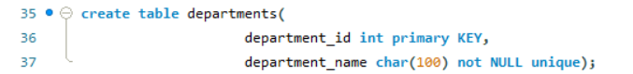

Location Table:
Establish a mechanism to automatically generate unique identifiers for each location, ensuring that they are incremented sequentially.
Implement constraints to prevent the insertion of null and duplicate locations.
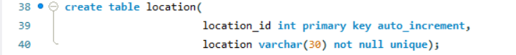

4. Employees Table:
- Guarantee that each employee has a distinct identifier.
- Create a restriction to ensure that the employee's name is always provided.
- Limit the acceptable values for the "gender" field to only 'M' or 'F'.
- Enforce a condition to ensure that the employee's age is 18 or above.
- Automatically assign the current date to the "hire_date" field if not specified.
- Establish links between the "department_id" and "location_id" fields in the "employees" table and their respective tables.
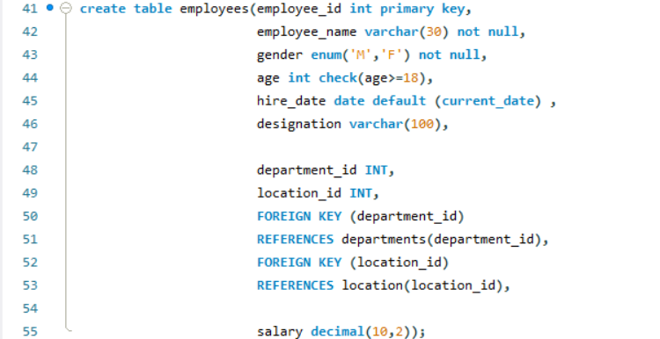
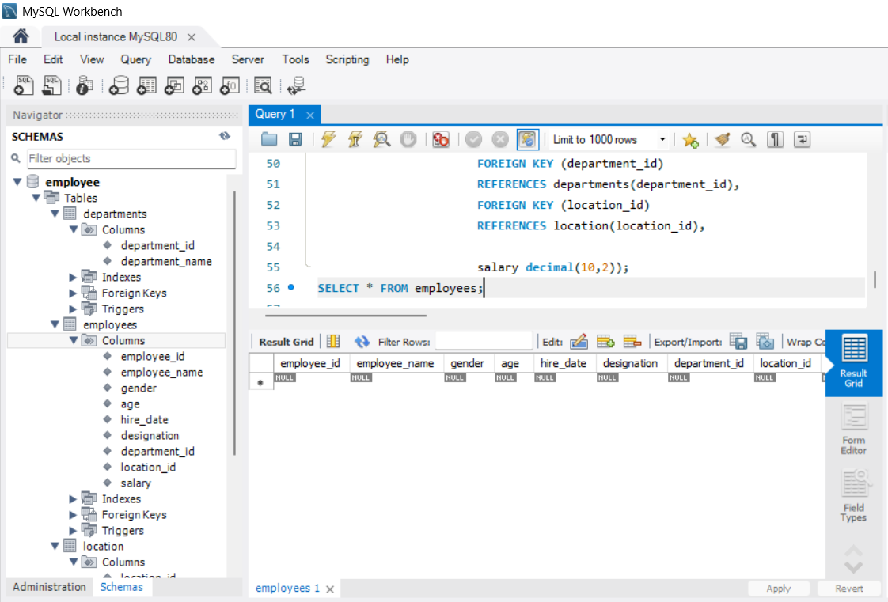

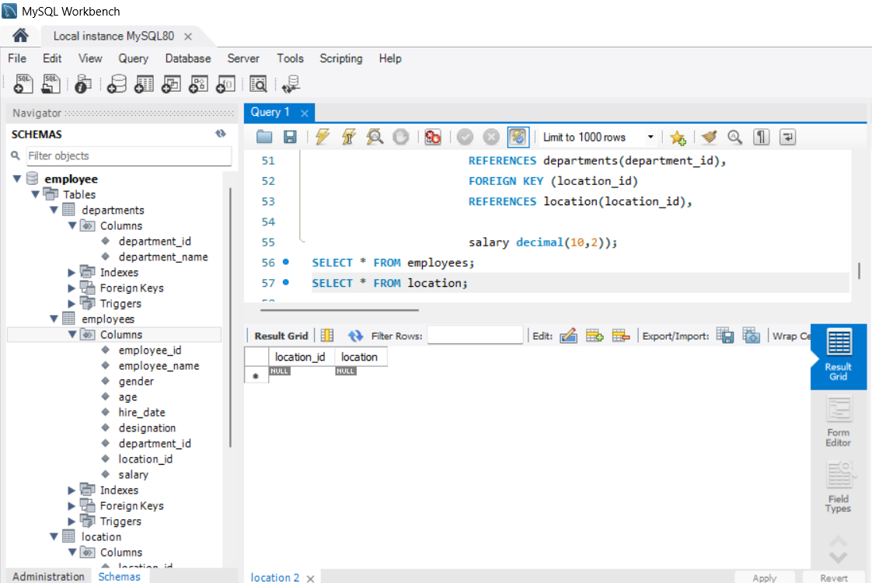

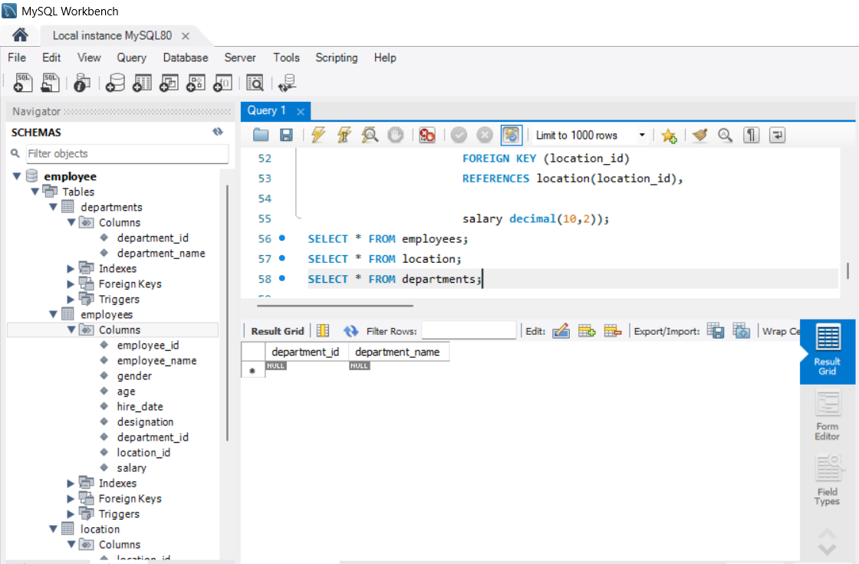
CODE
create database employee;
use employee;
create table departments (
department_id int,
department_name char(100));

create table location (location_id int,
location varchar(30));
create table employees (
employee_id int,
employee_name varchar(50),
gender enum( 'M','F'),
age int,
hire_date date,
designation varchar(100),
department_id int,
location_id int,
salary decimal(10,2));
alter table employees
add column email varchar(50);
alter table employees
modify column designation varchar(200);
alter table employees
drop column age;
alter table employees
rename column hire_date to date_of_joining;
rename table departments to Departments_Info;
rename table location to locations;
truncate table employees;
drop table employees;
drop database employee;
CREATE DATABASE employee;
USE employee;
create table departments(
department_id int primary KEY,
department_name char(100) not NULL unique);
create table location(
location_id int primary key auto_increment,
location varchar(30) not null unique);
create table employees(employee_id int primary key,
employee_name varchar(30) not null,
gender enum('M','F') not null,
age int check(age>=18),
hire_date date default (current_date) ,
designation varchar(100),
department_id INT, location_id INT,
FOREIGN KEY (department_id)
REFERENCES departments(department_id),
FOREIGN KEY (location_id)
REFERENCES location(location_id),
salary decimal(10,2));
SELECT * FROM employees;
SELECT * FROM location;
SELECT * FROM departments;
---------------------------------------------------------------------------

